2.1 Postman Setup

This section will guide you to understand:

* Postman
* Importance of Postman
* Installation of Postman

This guide has two subsections, namely:

* + 1. Installing Postman
    2. Setting up Postman

**Step 2.1.1: Installing Postman**

* Postman is already installed in your practice lab. Refer QA to QE lab guide -- Phase 3 for more information.

**Step 2.1.2: Setting up Postman**

* Open Postman and click on the sign up button to create a Postman Account.

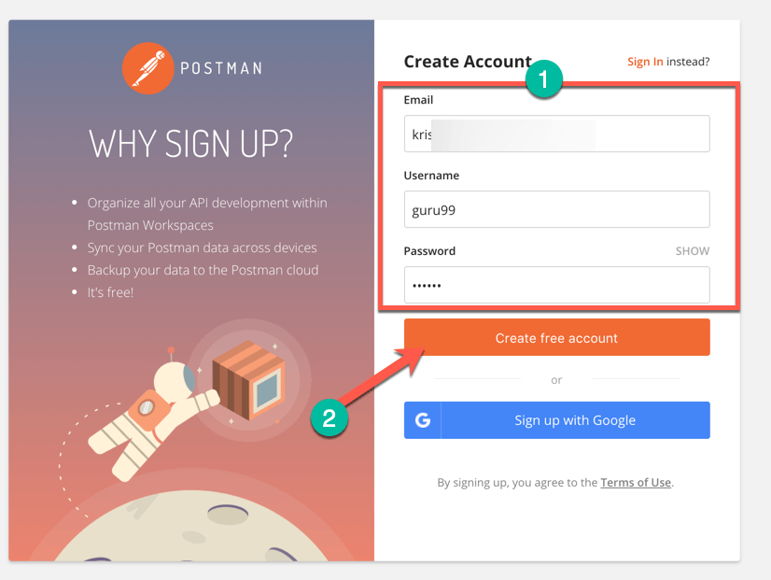

* NOTE: There are two ways to sign up for a Postman account. One is to create your own Postman account, and the other is to use a Google account. Though Postman allows users to use the tool without logging in, signing up ensures that your collection is saved and can be accessed for later use.
* Select the required workspace tools.
* Click on Save My Preferences.

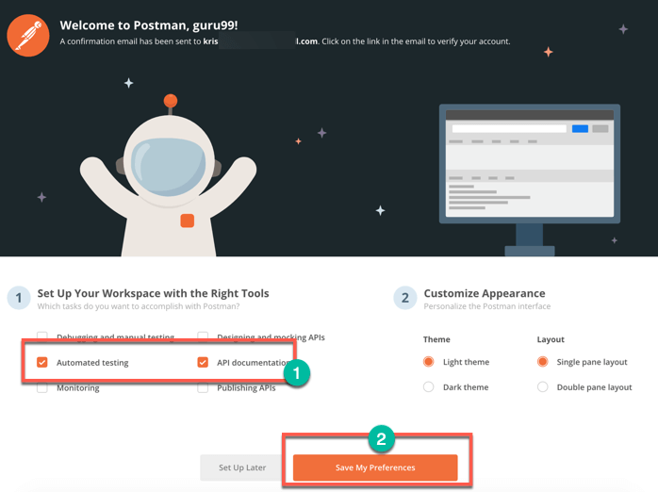

* You will see this Startup Screen below:

